LOSE TO WIN:
LED BY CERTIFIED HEATLH COACH & MYC HEALTH PLAN PROVIDER, MIRABAI HOLLAND

Mirabai Holland M.F.A, EP-C, CHC is one of the leading authorities in the Health and Fitness Industry, specializing in preventive, rehabilitative and lifestyle programs for age onset health issues.

Mirabai has been a trusted provider for Manatee Your Choice for over a decade with a history of success with many MYC health plan members. Her programs are implemented worldwide including at hospitals, fitness facilities, corporations, government agencies, and community centers in the USA, and globally!
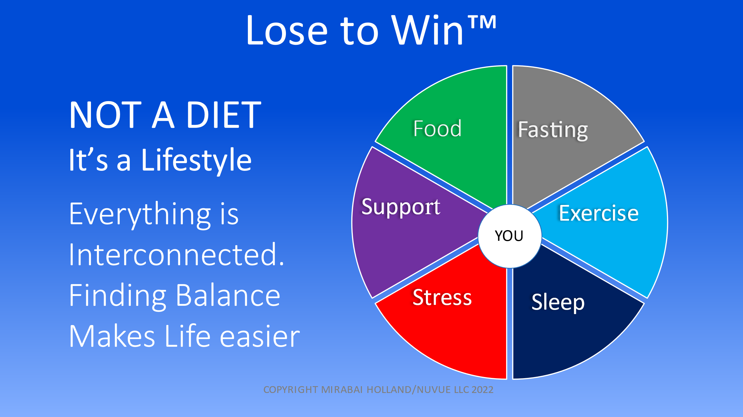
Lose to Win™ is designed to guide you through a weight management program, help you lose weight, address lifestyle factors, potential obstacles and ways to address them, to finally keep the weight off for good!

Lose to Win™ is an interactive 6-week education and health coaching program with a weekly group education seminar with live a live Q&A forum. Each participant will receive 2 personal one-on-one sessions in addition to the group education sessions.

The 6-week classes recur each Tuesday @ 12pm from Feb 14 – Mar 21

Register at www.manateeyourchoice.com/healthcoaching/losetowin

