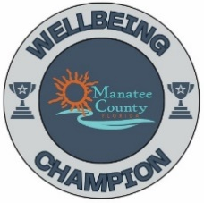
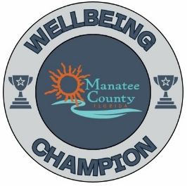
*Refer to manateeyourchoice.com/wellbeing/wellbeing-at-work for more information*
2024 Wellbeing Menu

Activity |  | Points | Date(s) Completed/Points Earned
 | Host a Wellness Advocate onsite to present (topics located on W@W page) | 10/each
 | Promote Tobacco Cessation Program | 5
 | Promote Wellbeing Workshops (Julie to send emails on each workshop) | 5/ Workshop
 | Promote Hinge Health | 5
 | Promote January IncentFit Challenge “New Year, New You” | 5
 | Promote an Emotional Wellbeing Challenge (see W@W page for ideas) | 5/each
 | Install a Gratitude Board / Shout Out Board (templates on website) | 5
 | Host a LAMP advocate onsite to present | 10/each
 | Share a LAMP voice recorded Video | 5
 | Promote Financial Workshops- 1x/Quarter! (BONUS: 1 pt for each employee who attends in your team. Please keep track of who attends, and I will have a list of all attendees) See flyer | 5/Workshop+ BONUS
 | Promote March Money Madness Challenge | 5
 | Promote Deferred Compensation benefit – Voya (info on W@W page)
 | Observe a Health Awareness Campaign (Wear Red, Pink, Green etc.) Get Team Picture | 5
 | Collect and donate candy for troops over Halloween (Julie to email in Sept) | 5
 | Promote blood drive (email to go out) | 5 per event
 | Host Team Building or Wellness Event (Wellness Team can assist with ideas) | 10
 | Promote Pink Pumpkin Department Challenge (Julie to email in Sept) *BONUS 5 pts if participate and show picture!* | 5
 | Host a Potluck Lunch at your worksite | 10
 | Build a W@W Bulletin Board using flyers from Banquet folder or email. Must show picture of board when turning in scorecard! | 10
 | Attend Wellness Champion Banquet/Meet with Julie to review 2024 | 10
 | Create your own activity! | 5
* Documentation can be in the form of email records, or photos of “day-of” participation. *
Platinum: 95+ Points
Gold: 75-94 Points
Silver: 56-74 Points
Bronze: 40-55 Points

