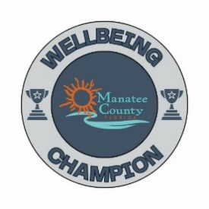
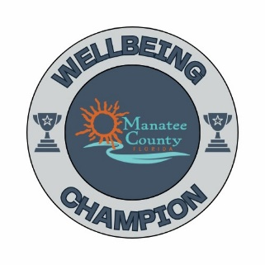
*Refer to manateeyourchoice.com/wellbeing/wellbeing-at-work for more information*
2025 Wellbeing Menu

Activity | Points | Date(s) Completed/points earned
Host Wellness Care Team member for presentation (topics on W@W page) | 10/each
Host Nutrition Assessment Event (4+ needed to come out) | 10
Promote Wellbeing Workshops and Challenges | 5/ Workshop
Promote Hinge Health | 5
Host Diabetes Survival Skills Course with Marcus (1-hour on-site) | 10
Host Wellbeing Expo with Care Team on-site | 10/each
Host a mini exercise class | 10
Host an Emotional Wellbeing Challenge (see W@W page for ideas) | 5/each
Install a Gratitude Board / Shout Out Board (templates on website) | 5
Host LAMP advocate onsite to present | 10/each
Host a meditation/relaxation class OR create a “Zen space” at work | 10
Promote Financial Workshops- 6 this year (BONUS: 1 pt for each employee who attends in your team. Please keep track of who attends, and I will have a list of all attendees) See flyer | 5/workshop
Promote March Money Madness Challenge | 5
Promote Deferred Compensation benefit – Voya (info on W@W page) | 5
Observe Health Awareness Campaign (Wear Red, Pink, Green etc.) Get Team Pic! | 5/campaign
Collect and donate candy for troops over Halloween (Julie to email in Sept) | 5
Promote blood drive and/or Mobile Dermatology | 5/each
Host your own Team Building/Wellness Event (Care Team can assist with ideas) | 5 per event
Enter the Pink Pumpkin Department Challenge (Julie to email in Sept) Must get pic! | 10
Host a Potluck Lunch at your worksite | 10 each
Attend Wellness Champion Banquet/Meet with Julie to review 2025 | 10
Create your own activity for your employees! | 5 each
Build a W@W Bulletin Board using flyers from Banquet folder or email. Must show picture of board when turning in scorecard! | 10
Platinum: 100+ Points
Gold: 85-99 Points
Silver: 70-84 Points
Bronze: 55-69 Points

