Questions? Contact Florey Miller fmiller@manateeyourchoice.com 941-748-4501 x6410

Steps to get started
- Go to fullplateliving.org https://www.fullplateliving.org/ Click on the green button

- Scroll down and click on another green button

- Fill out the box for No Charge Full Plate Living Membership, then click Sign up for free

- A page will pop up saying,

- Scroll down and click on the green button

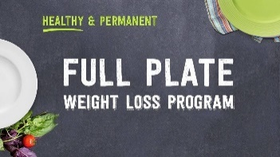
- On the right side, you will see Full Plate Weight Loss Program
Click on the blue button

- Lessons and links are listed on this page. You can watch any or all of the lessons, however the quiz will contain questions from these lessons:

- Lesson 1 How to lose weight and feel full
- Lesson 3 An Easy Way to Measure How Much Fiber You’re Eating
- Lesson 4 The First Habit You Need to Succeed on Full Plate
- Lesson 7 Supper
- Lesson 8 The Habit of Maintaining a Weight Loss Friendly Environment
- Lesson 9 Beans
- Lesson 10 Fruits and Vegetables
- Lesson 11 Cooked Whole Grains
- Lesson 12 The Habit of Turning Negative Thoughts into Positive Ones
- Lesson 14 How to Drink Less of your Calories
- Lesson 15 How to Snack Smarter

- Please take the quiz to confirm you have completed viewing the lessons, here: https://www.classmarker.com/online-test/start/?quiz=rbx60db78bff1c07
You must get 50% to pass. If you do not pass, you can repeat the quiz until you do pass.
Classmarker will send us a list of those who have passed the quiz. You just need to keep the certificate.

