**Healthy Pregnancy Tips**

**Take Prenatal Vitamins**

Prenatal vitamins can help prevent birth defects. They also help your baby grow healthy and strong and may help you with morning sickness. You’ll want to make sure your prenatal vitamin has folic acid, iron and calcium in it.

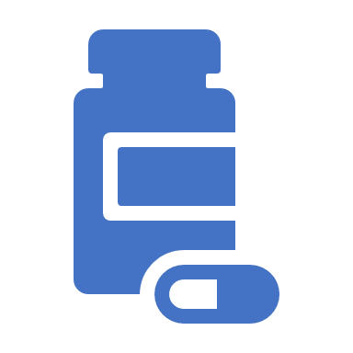

**Manage Substance Use**

Avoid using alcohol, drugs or cigarettes. If you need help quitting, contact your care provider or call the Substance Use Disorder Helpline toll-free at 1-855-780-5955, available 24/7.



**Manage Morning Sickness**

Morning sickness can be hard on you and should be taken seriously. Make sure you drink plenty of water and eat small meals often. Foods like rice, bananas and cereal may be easier on your stomach. Stay away from spicy or fatty foods.





**Keep Moving**

Exercise is always important, but especially during pregnancy. Regular, daily walks are an easy way to keep moving. It’s likely you will feel tired as you get later in your pregnancy. Always listen to your body and talk to your care provider before trying a new exercise routine.

**Manage Stress**

A new baby can make you feel worried. Your prenatal and postpartum appointments are a form of self-care. Talk to your care provider if you are **feeling sad, overwhelmed or anxious** or contact the YourChoice LAMP Line @ (941) 741-2995.

**Additional Tips**

* Stay Connected To Others; Having a support network is important.
* Drink Enough Water; All moms especially those breastfeeding should be drinking enough water.
* Shower & Dress Each Day; Creating a routine of normalcy can impact your overall wellbeing.
* Relax When Baby Naps; Take a moment when the baby is sleeping to recharge you own battery. The dishes can wait.